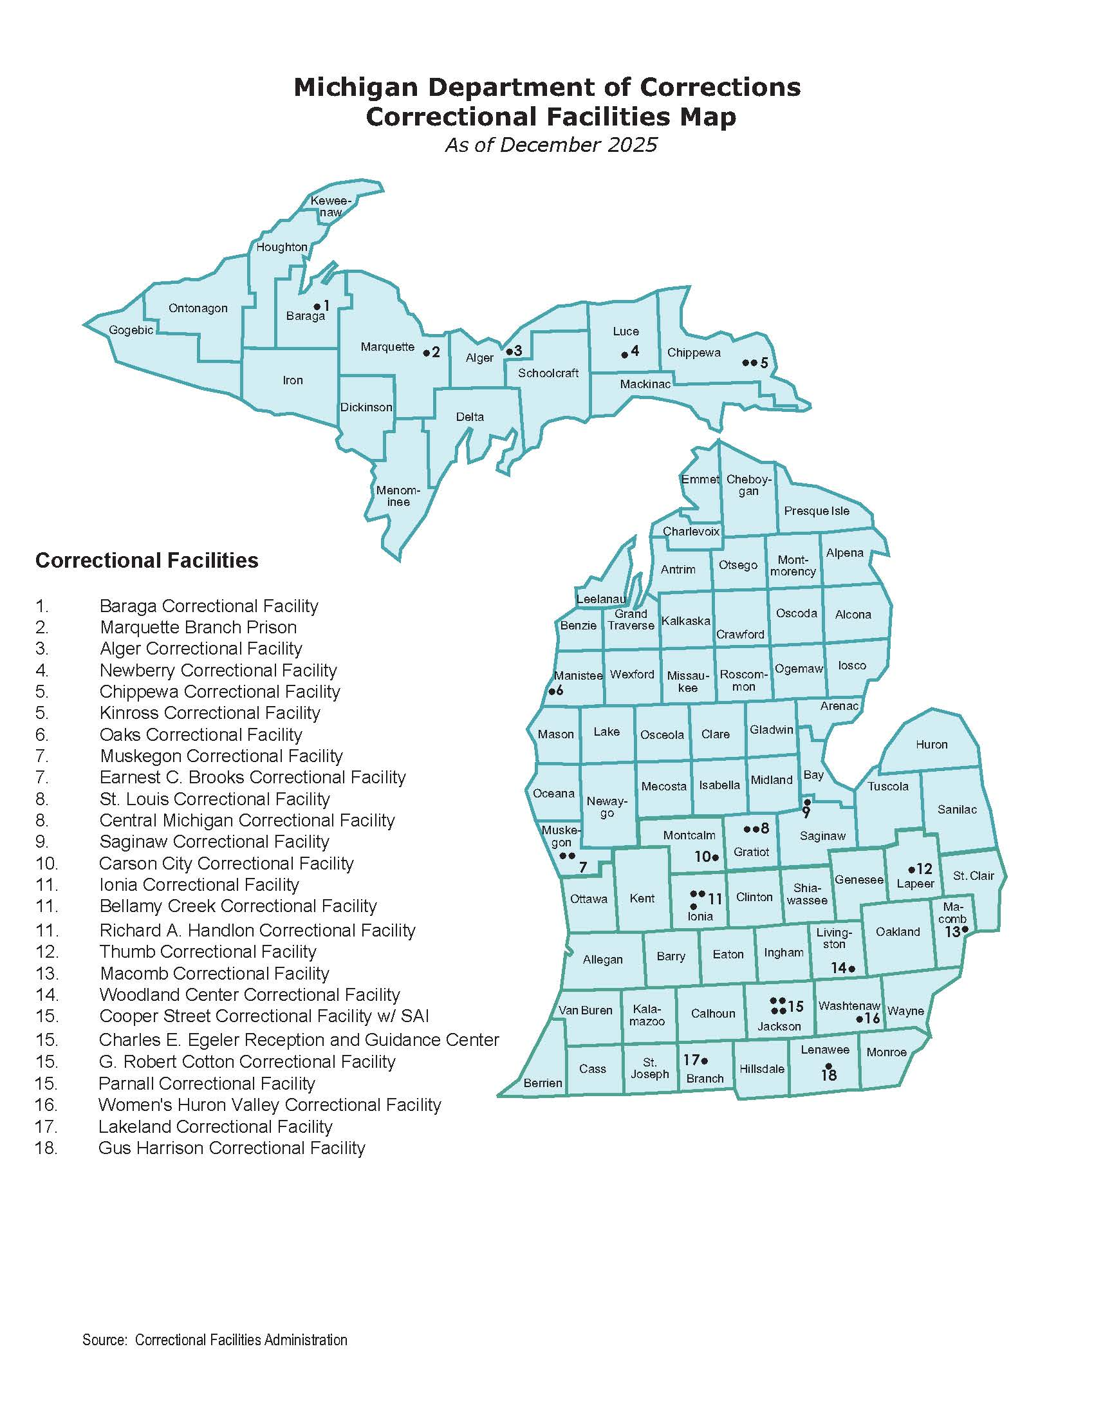
Schedule f – mdoc facilities map
This is not an all-inclusive list of MDOC locations. MDOC may require temporary staffing be placed at other facilities not listed in this Contract. The Contractor must work with the State (MDOC) to place staff as required.

